**Summer training report/ synopsis/ minor project**

**ON**

**Quiz Application using Python & MySQL**

A project report/synopsis SUBMITTED IN PARTIAL FULFILLMENT OF

THE REQUIREMENTS FOR THE AWARD OF

Bachelor OF engineering

In

Computer science and engineering

Submitted BY

Ravi Verma

roll NO: CO19352

Under THE SUPERVISION OF

Dr. Ankit Gupta & address OF COMPANY/INDUSTRY/TRAINING INSTITUTE / guide



Chandigarh college of engineering and technology

(degree wing)

Government Institute under Chandigarh (UT) Administration, Affiliated to Panjab University

, Chandigarh

Sector-26, Chandigarh. PIN-160019

July, 2020

CANDIDATE’S DECLARATION

I hereby declare that the work presented in this report entitled “ Quiz Application using Python and MySQL”, in fulfillment of the requirement for the award of the degree Bachelor of Engineering in Computer Science & Engineering, submitted in CSE Department, Chandigarh College of Engineering & Technology(Degree Wing) affiliated to Punjab University, Chandigarh, is an authentic record of my work carried out during my degree under the guidance of Dr. Ankit Gupta. The work reported in this has not been submitted by me for the award of any other degree or diploma.

Date : 30/07/2020 Ravi Verma

Place : CO19352

CERTIFICATE

This is to certify that the Project work entitled “Quiz Application using Python and MySQL” submitted by Ravi Verma in fulfillment for the requirements of the award of Bachelor of Engineering Degree in Computer Science & Engineering at Chandigarh College of Engineering and Technology (Degree Wing), Chandigarh is an authentic work carried out by him/her under my supervision and guidance. To the best of my knowledge, the matter embodied in the project has not been submitted to any other University / Institute for the award of any Degree.

Date : Dr.Ankit Gupta

Place : Deptt of CSE

CCET(Degree Wing)

Chandigarh

ACKNOWLEDGEMENT

This project enabled me to apply my theoretical knowledge and get practical hands-on experience.

ABSTRACT

As technology is getting more accessible day by day. Digitization is happening in every sector. With the digitization there arises the demand for new software applications that cater to the needs of the user. One such field is education which has witnessed new approaches to teach students using the Internet and Technology. Online learning is one such approach. Online learning also requires new methods to evaluate student performance. Quiz format tests are easy to evaluate and are perfect to test student’s knowledge. But it requires new software solutions to make it possible. One such solution is Quiz application using Python and MySQL. The application is simple yet powerful.

CONTENTS

Students’s declaration…………………………………………………………. i

Certificate by the guide…………………………………………………………ii

Acknowledgement………………………………………………………………iii

Abstract………………………………………………………………………….iv

List of tables…………………………………………………………………….v

List of figures……………………………………………………………………vi

Chapter 1 - <Name of the Chapter> ……………………………………………1

1.1 <Name of the topic>………………………………………….

1.2 < >……………………………………………………..

Chapter 2 - <Name of the Chapter> ……………………………………………

Certificates

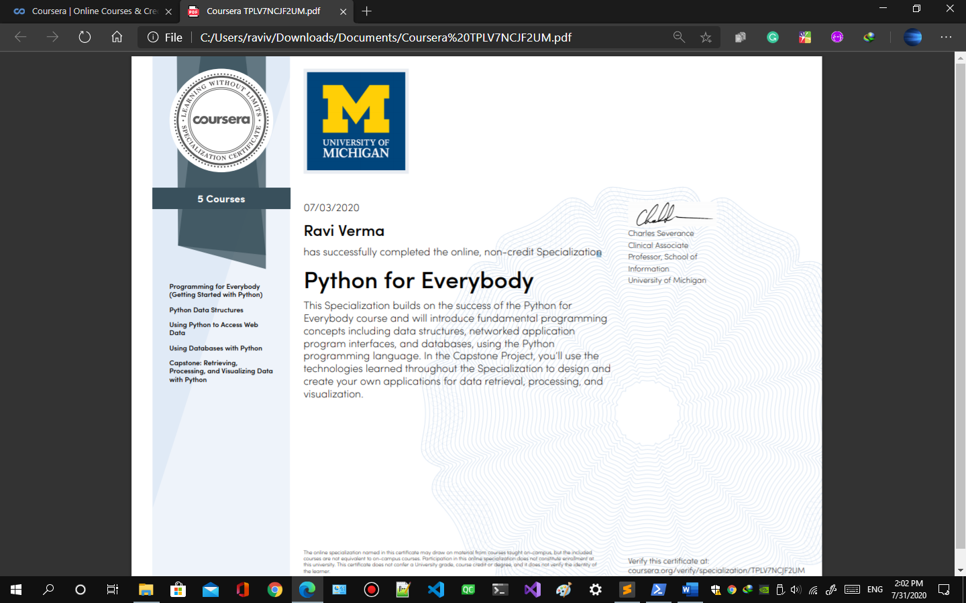

Verify at : <https://www.coursera.org/account/accomplishments/specialization/certificate/TPLV7NCJF2UM>

Development Environment

Language: Python 3.4

Operating System: Windows 10.

Processor: Intel Pentium.

Architecture: x86

Specifications

Operating System: Windows, Mac and Linux

Processor: Intel Pentium.

Architecture: x86

RAM: 60 Mb

Dependencies

sqlite3

sqlite3 is a standard python module used for accessing, storing and modifying data in a database from a python application.

tkinter

tkinter is a standard python module used for creating graphical user interface applications in python. It is available with a standard python installation and is cross-platform i.e compatible with Windows, Mac, and Linux operating systems.

json

json is a standard python module used to parse and create JSON files.

matplotlib

matplotlib is a python module used to plot graphs and charts.

os

datetime

time

Project structure

1. app.py
2. user.py
3. quiz.py
4. quizeditor.py

**app.py**

app.py contains the Application class. This class provides the user login and signup window. User can create an user or admin account for him/her from signup window. The signup for admin account requires permission from the admin.

The user/admin can login or exit. If the user/admin logs in successfully he/she is provided with a admin or user menu depending upon the type of account he/she used to login.

The admin menu has three options

* Quiz
* Quiz editor
* User dashboard

The user menu has three options

* Quiz
* User dashboard

**quiz.py**

quiz.py contains Quiz class which provides the user/admin to attempt the quizzes. It fetches all the available quizzes from the database and provides admin/user a menu of available quiz options. If there is no Quiz available at that moment it displays a message about it.

User/admin can select from the available options and attempt the quiz. It also checks following things before allowing the user to attempt the quiz.

* Response limit
* Date and time

If the above parameters are not satisfied the user is not allowed to attempt the quiz and the message about it is displayed on the right side of the option.

If the above parameters are satisfied it allows the user to attempt the quiz. It displays instructions about the quiz which are auto generated. The user can either accept or decline. If the user accepts response is counted and if the user declines response is not counted. If the quiz has time limit set it starts a timer and automatically submits the response when the time limit is exceeded.

User is provided with multiple choice questions to attempt.

User can either exit or submit from the quiz. In the both scenario response is counted.

**quizeditor.py**

quizeditor.py contains QuizEditor class which is used to create and edit quizzes. The admin can only edit and save quizzes. The quizzes are added to MySQL database when saved. The QuizEditor has a menu at the top it has two options

* File
* About

File option has

* New
* Open
* Save
* Close
* Exit

New option creates a new quiz.

Open option fetches an already saved quiz from MySql Database after asking to save any opened or new quiz.

Save option saves the quiz opened or new quiz.

Close option closes any quiz if it’s opened or new quiz after asking to save it.

Exit option exits from the QuizEditor.

**user.py**

It contains the User class which stores user/admin details during run time and provide the user/admin dashboard. The user dashboard has two view admin mode and user mode.

User mode view has options to reset password and view previous quiz responses. If there are no responses available it shows a message about it. The user can view their response and export them into a file.

Admin mode view has all the capabilities of User mode and admin has the ability to export all the individual quiz responses into a file. Which he/she can then use to analyze the data.

Usage

1. **How to Signup**
   1. **How to make user account**
      1. Start the application
      2. A login window will appear on the screen like below. 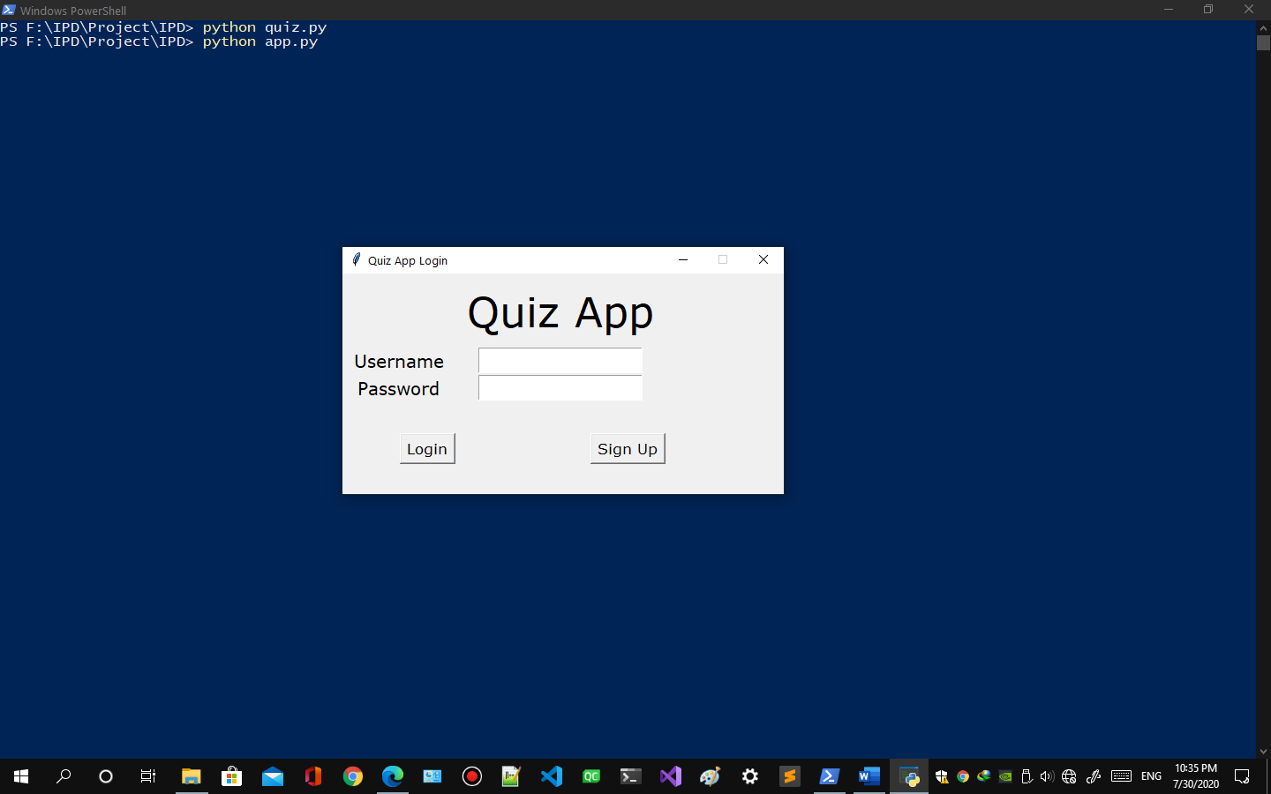
      3. Click on the signup button
      4. Signup window like below will appear. 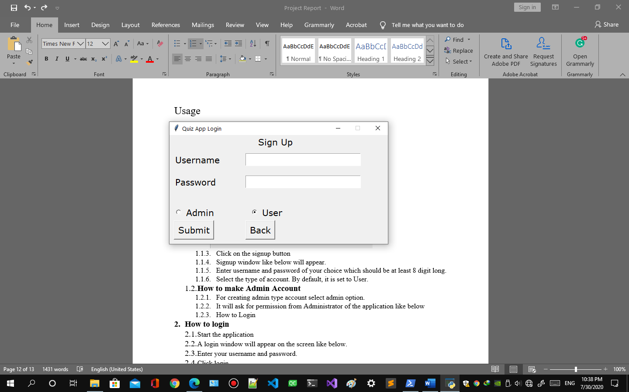
      5. Enter username and password of your choice which should be at least 8 digit long.
      6. Select the user type of account. By default, it is set to User.
      7. Click Submit Button.
      8. A message will appear after successful account creation. 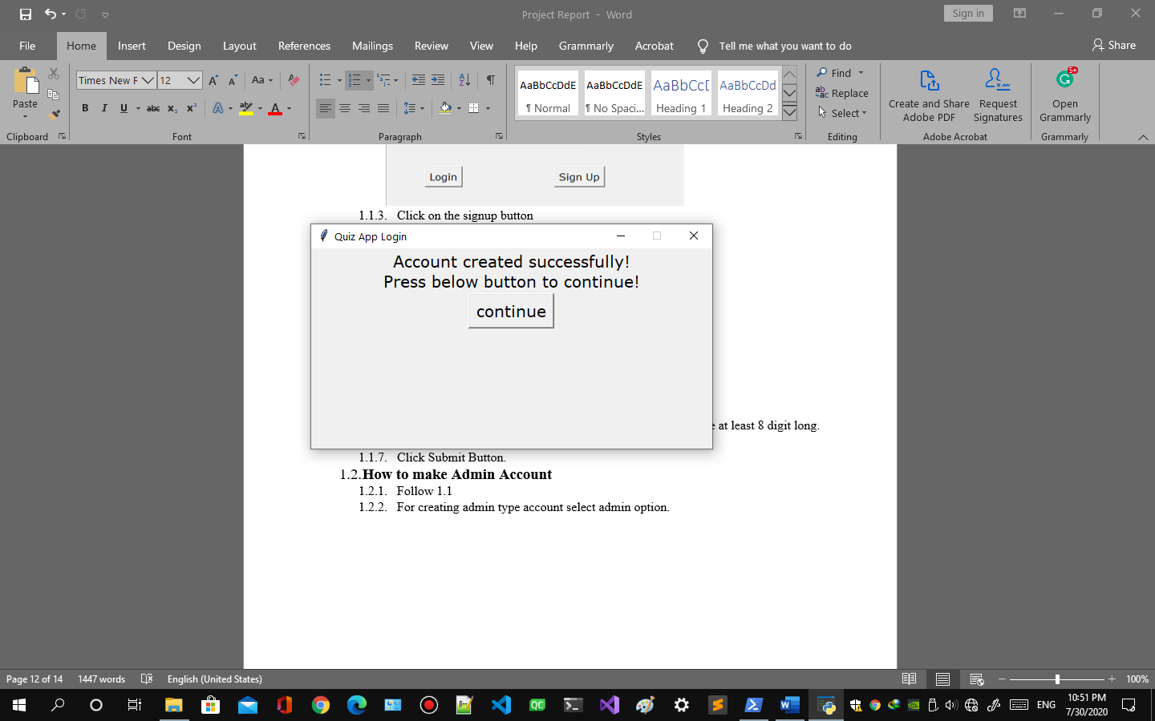
      9. Press continue button to login.
   2. **How to make Admin Account**
      1. Follow 1.1.1 to 1.1.6.
      2. For creating admin type account select admin option.
      3. It will ask for permission from Administrator of the application like below 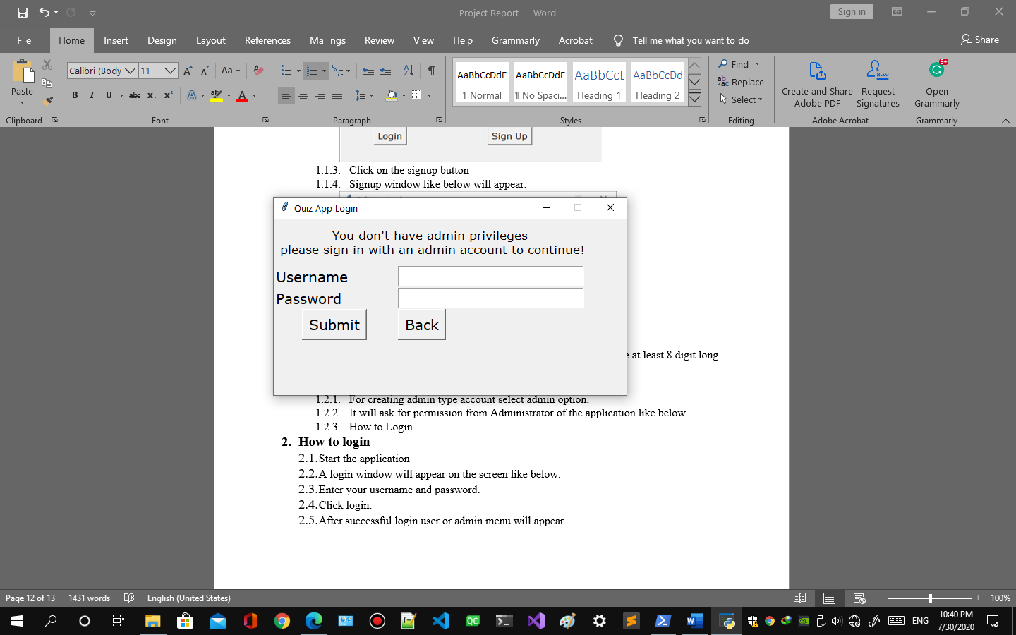
      4. Enter username and password of any administrator account to continue
      5. Click submit button.
      6. A message will appear after successful account creation. 
2. **How to login**
   1. Start the application
   2. A login window will appear on the screen like below. 
   3. Enter your username and password. 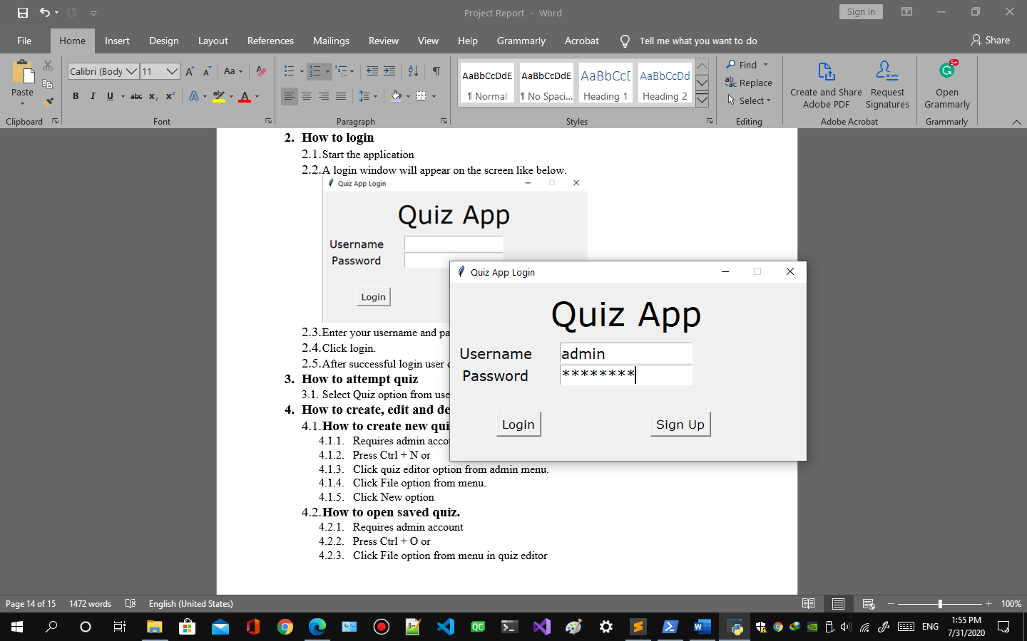
   4. Click login.
   5. After successful login user or admin menu will appear. 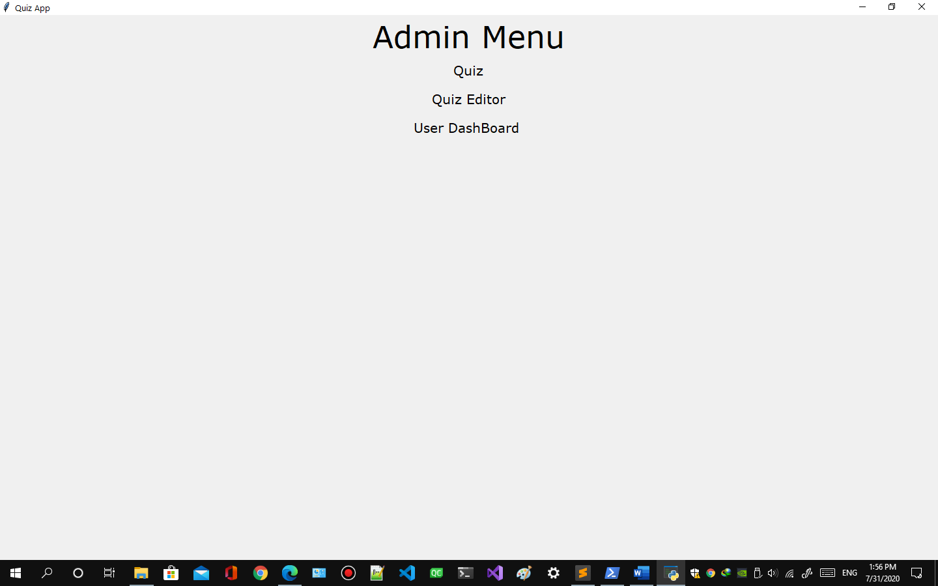 or 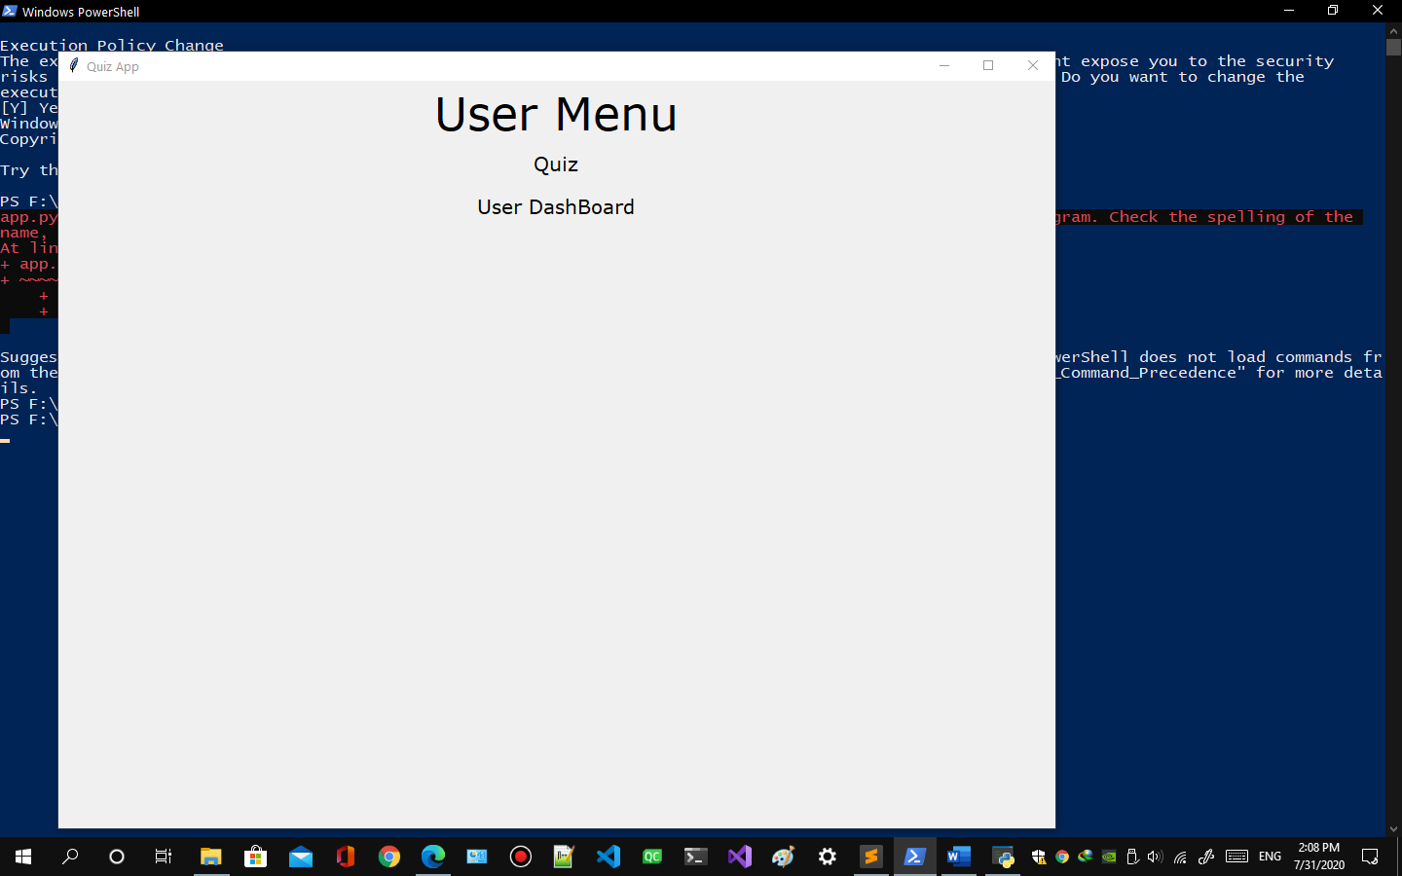
3. **How to start a quiz**
   1. Select Quiz option from user or admin menu.
   2. Quiz menu will appear like this is there are no quizzes available.
   3. Quiz menu will appear like this if there are quizzes available.
   4. Click on the quiz you want to attempt.
   5. If you have exceeded response limit of quiz a message will appear.
   6. If the scheduled date does not match the current date a message will appear.
   7. If the scheduled time does not match the current time a message will appear.
   8. Instruction will appear.
   9. Click Accept to start the quiz.
   10. Click Decline to quit the quiz but it won’t be counted
4. **How to attempt a quiz**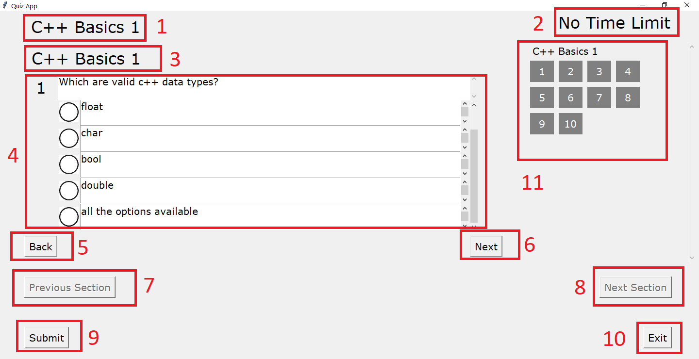
   1. Name of quiz
   2. Time limit of quiz
   3. Name of section in the quiz
   4. Question and options
   5. Back button to go to previous question in section in quiz
   6. Next button to go to next question in section in quiz
   7. Previous section button to go to previous section in quiz
   8. Next section button to go to next section in quiz
   9. Submit button to submit the response.
   10. Exit button to exit the quiz.
   11. Jump to any question of any section by clicking the question number.
5. How to View Quiz result
   1. From user menu or quiz menu select user dashboard option.
   2. A user dashboard will appear.
   3. If there are no previous attempts a message will appear.
   4. If there are attempts available it will appear like this.
   5. Click the quiz name you want to view the result.
   6. The result will appear on right side.
6. How to save the quiz result
   1. Follow 5.1 to 5.6
   2. Click the export button on the bottom.
   3. It will ask the path and name to save.
   4. If the quiz result was saved successfully a message will popup
   5. If there are any errors occur whiling saving result a message will appear.
7. **How to create, edit and delete quiz**
   1. **How to create new quiz**
      1. Requires admin account.
      2. Click quiz editor option from admin menu.
      3. Press Ctrl + N or 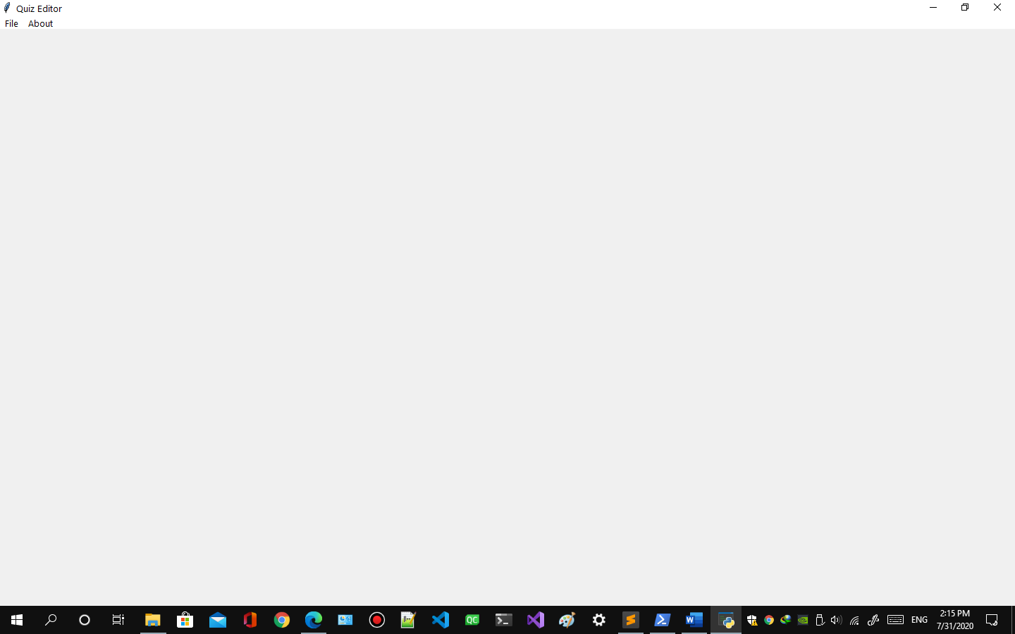
      4. Click File option from menu. 
      5. Click New option 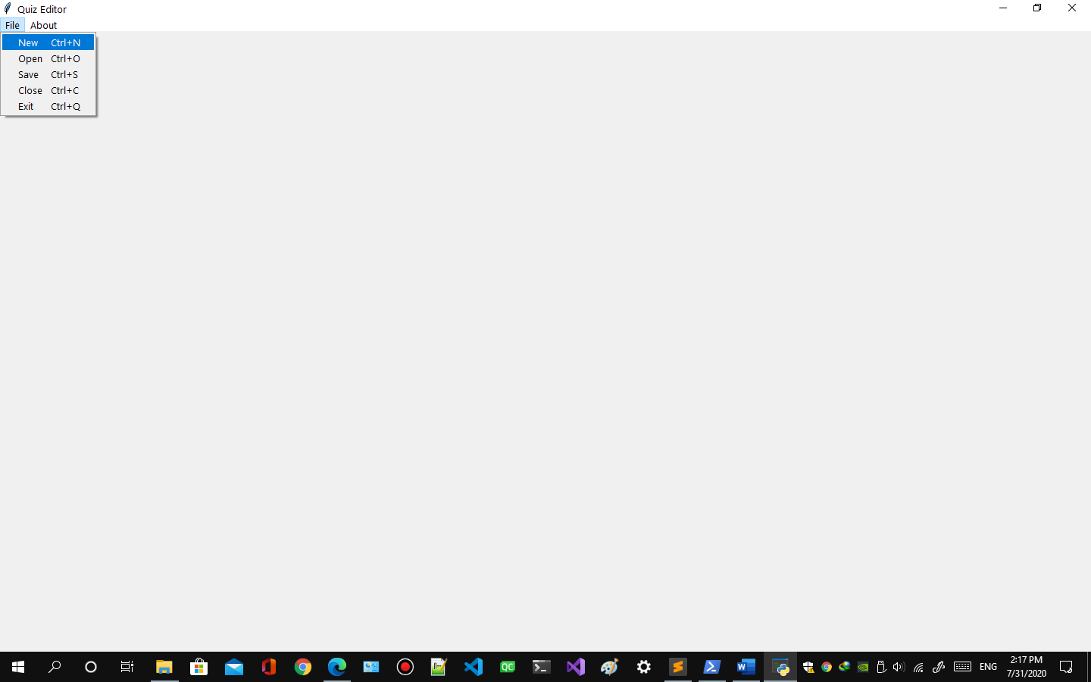
      6. If there is quiz opened already it will ask to save the already opened quiz 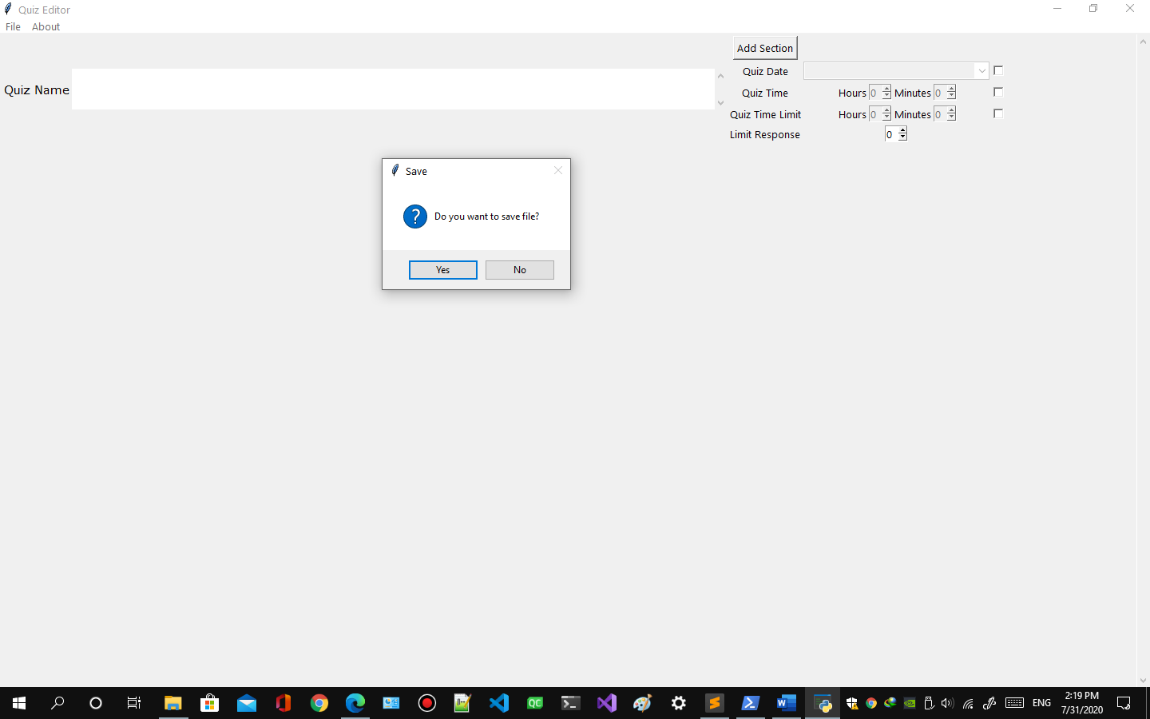
      7. New quiz will be created to edit. 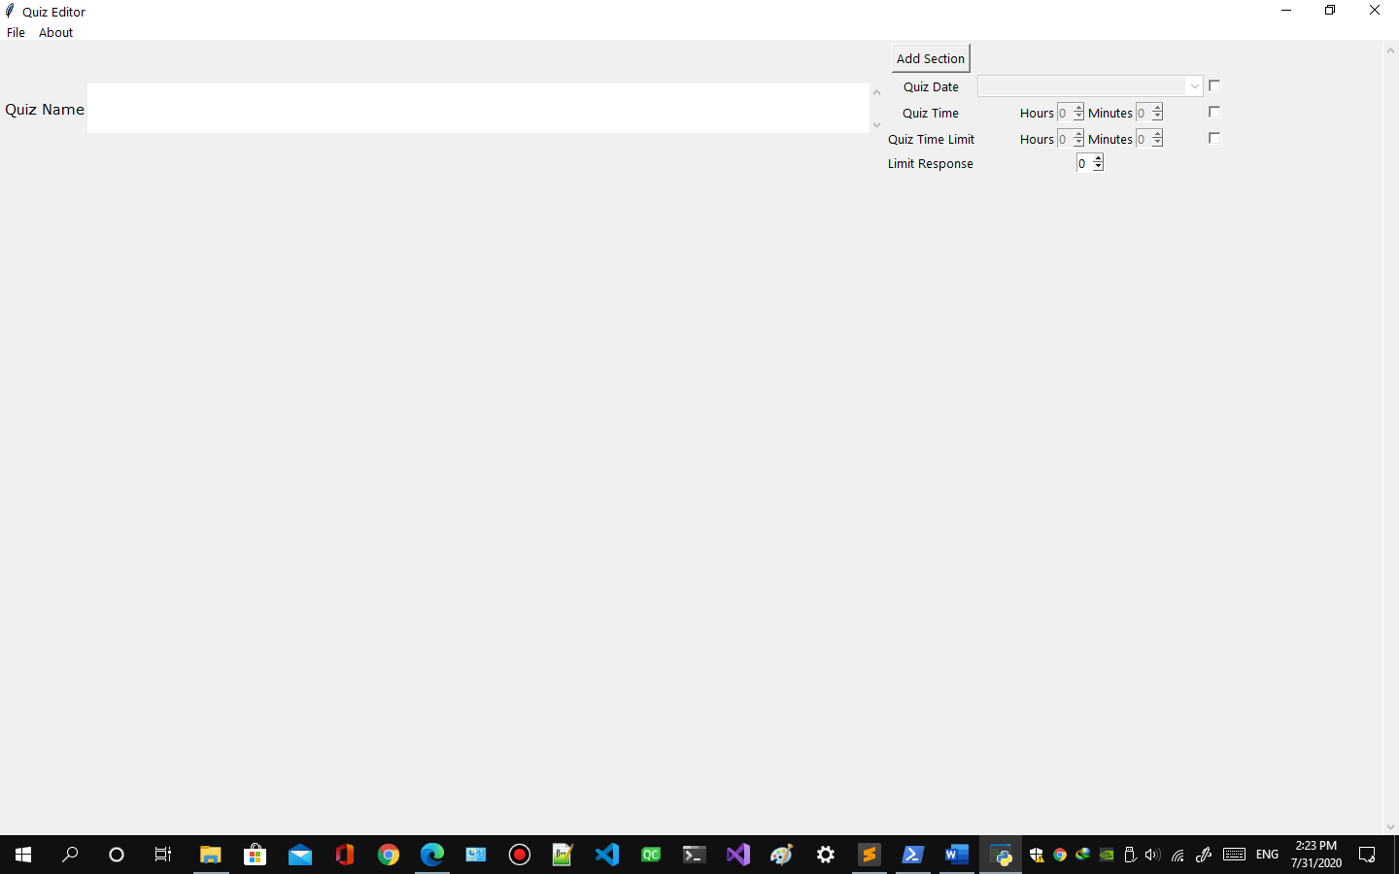
   2. **How to open saved quiz.**
      1. Press Ctrl + O or
      2. Click File option from menu in quiz editor
      3. Click open option 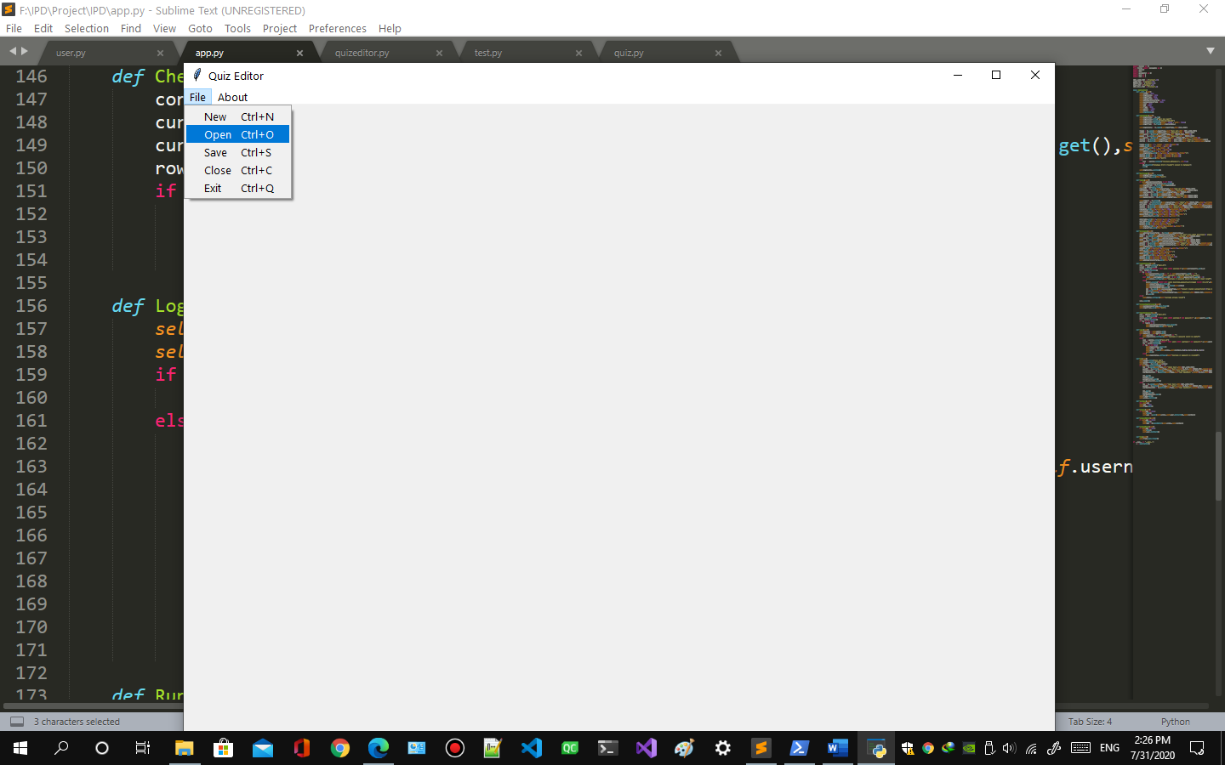
      4. Open window will appear like this if there are no quizzes saved already message will appear like this 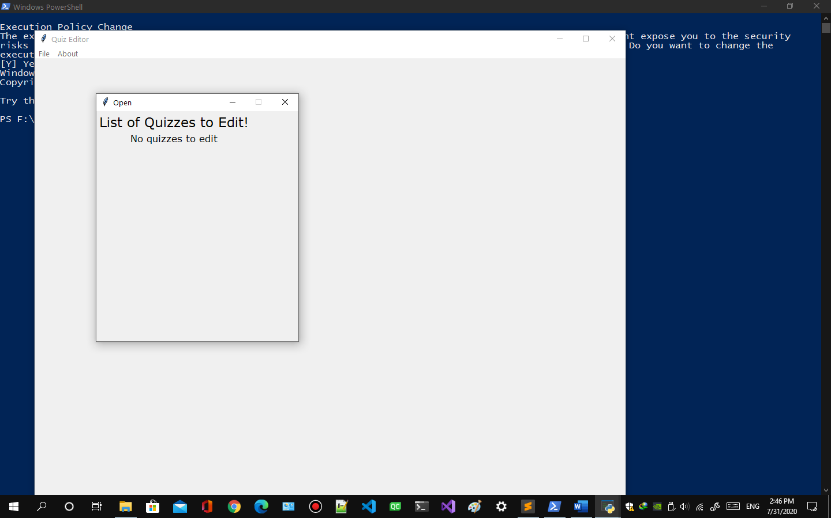
      5. Open window will appear like this if there are quizzes available 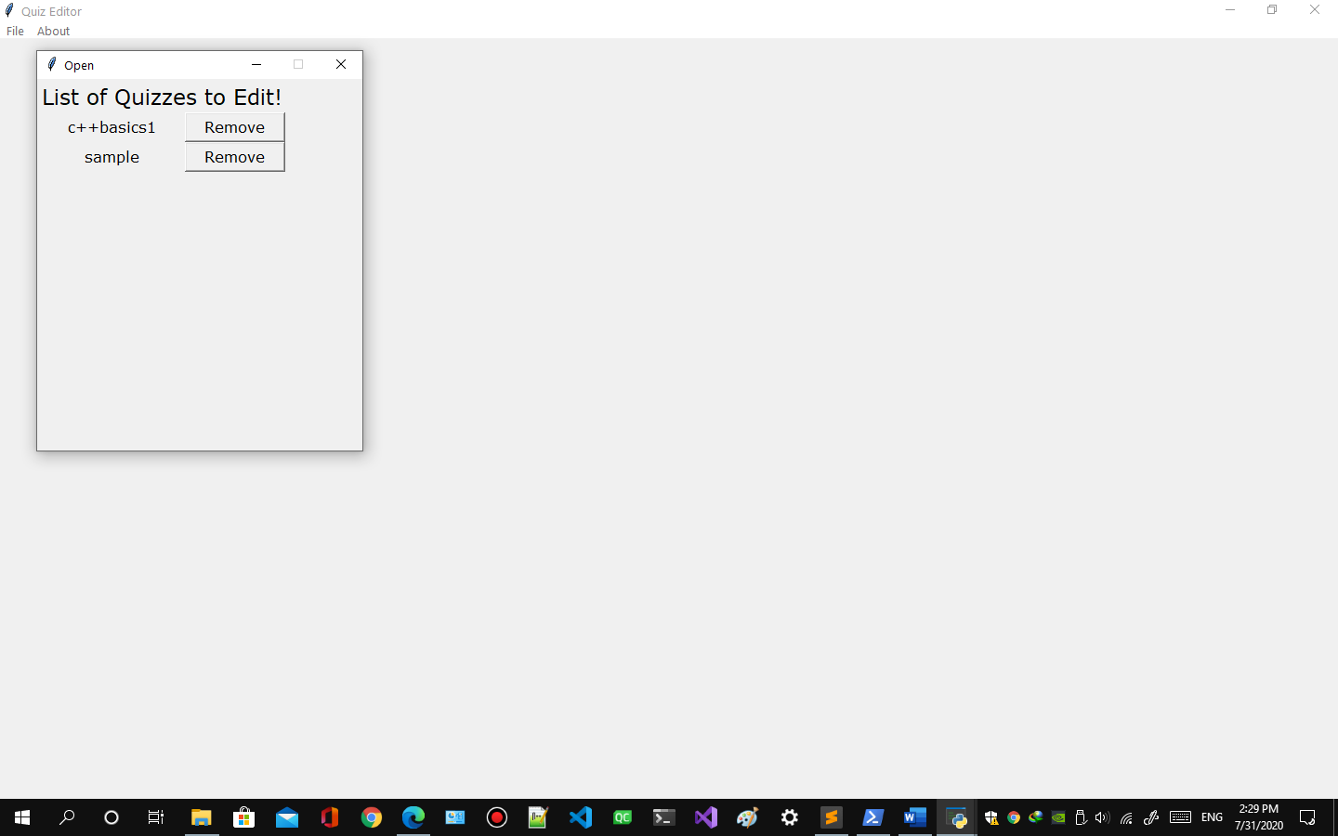
      6. Click the quiz you want to open.
   3. **How to save quiz**
      1. Press Ctrl + S or
      2. Click File option from menu in quiz editor.
      3. Click Save option.
   4. **How to remove quizzes**
      1. Click Remove button on the right side of the quiz you want to remove.
   5. How to Schedule Quiz
      1. Click
      2. Click
      3. Select
   6. How to set Time limit
      1. Click
      2. Set Hour and minutes
   7. How to add new section
      1. Click Add New Section button
   8. How to Add New Question
   9. How to Add New option
   10. How to Remove option
   11. How to